Sub Admin Management

Introduction
The Sub Admin Management module allows administrators to create and manage sub-admin accounts with specific access privileges. This helps in delegating responsibilities while maintaining control over system operations.

How to Add a Sub Admin

Step-by-Step Procedure
- Login to the system using Admin credentials.
- From the left navigation pane, click Users.
- Select Sub Admins.

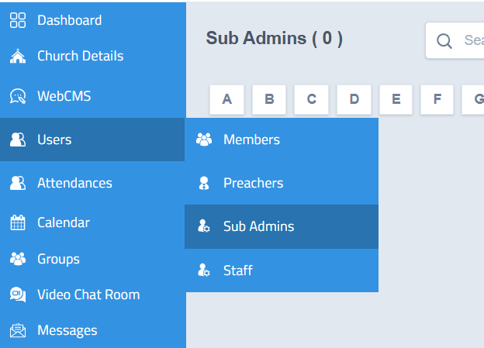

Adding a New Sub Admin
- Click the Add button.

- A new sub-admin registration form will open.

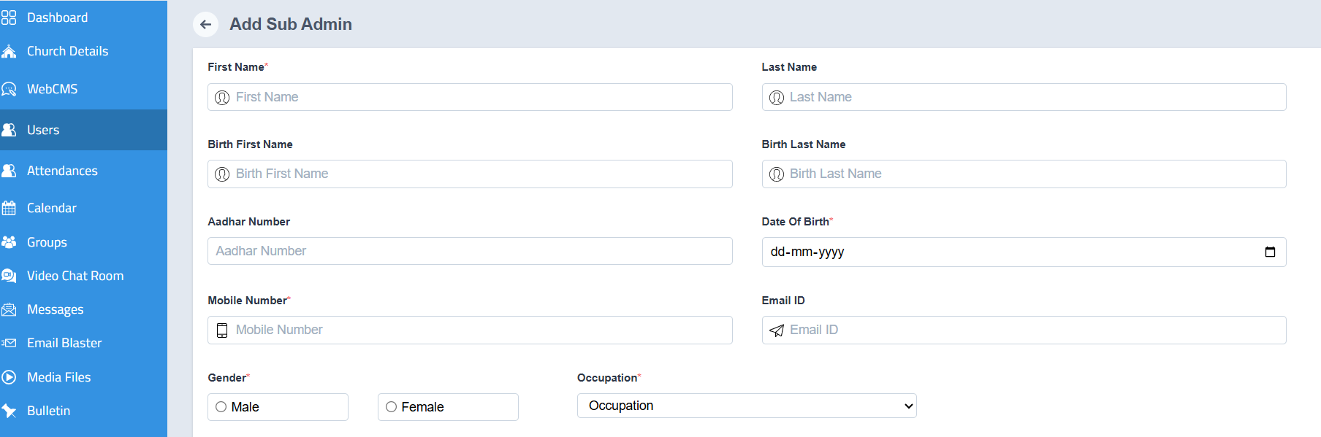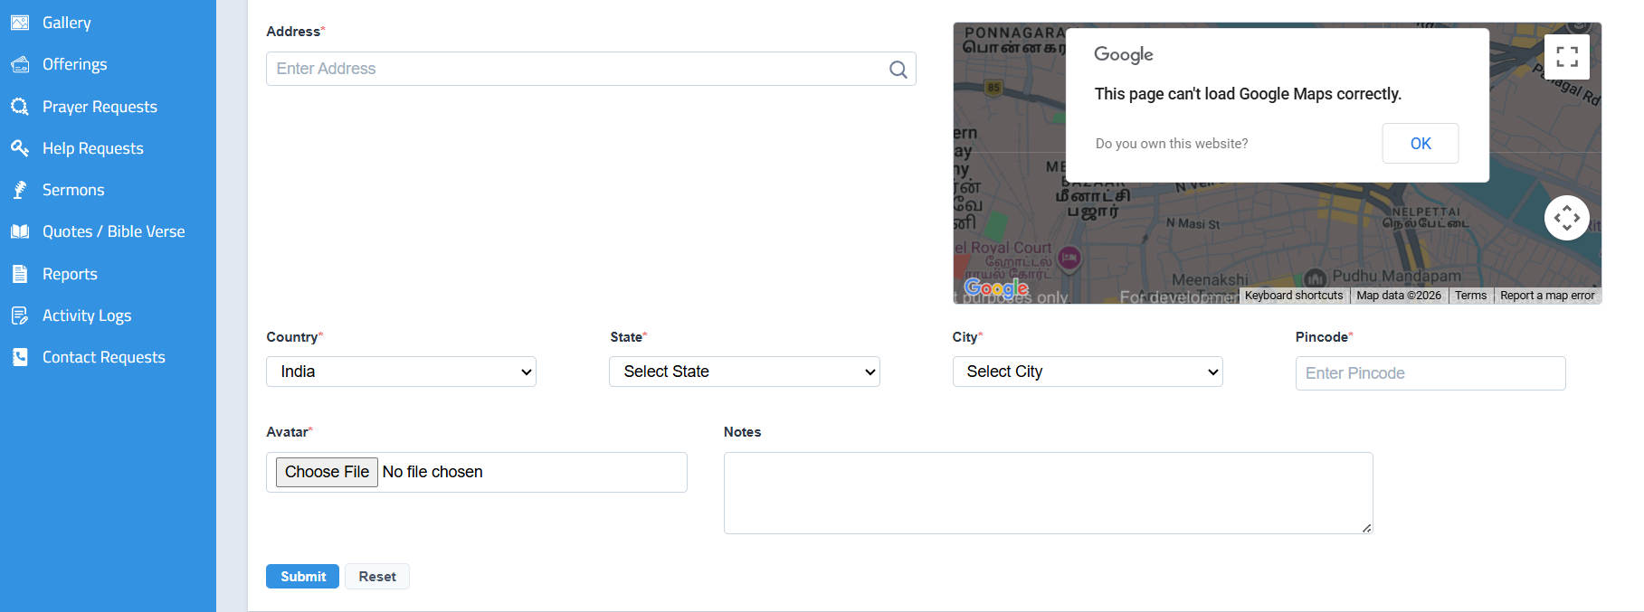

• Enter all the required details.
• Ensure the following key information is provided:
- Email ID (Important for login access)
- Other necessary profile details
• Click Submit.
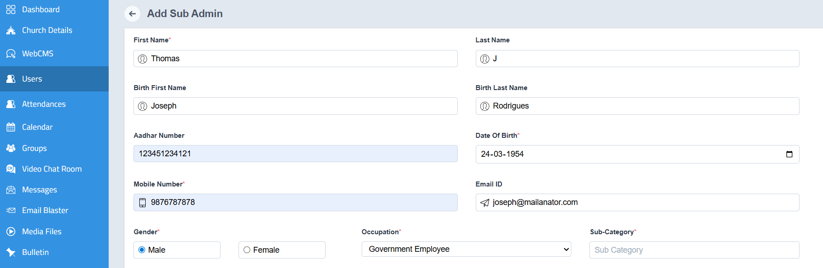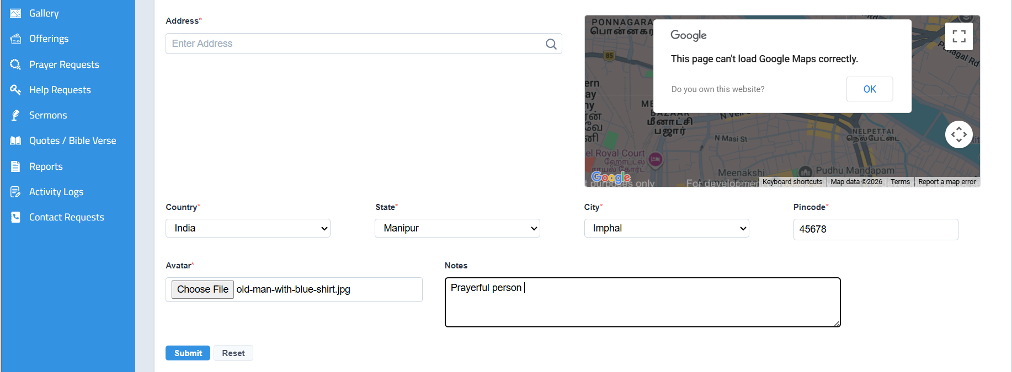
How to Use Search and Filter
- Records can be searched using the search bar by entering the name of the required entry.
- Users can also browse records using alphabetical sorting for quick shortlisting.
- This feature helps in easily finding specific members, parents, staff, or other records without manually scrolling through the entire list.
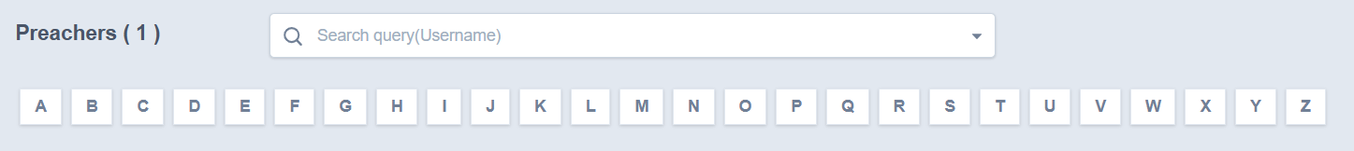
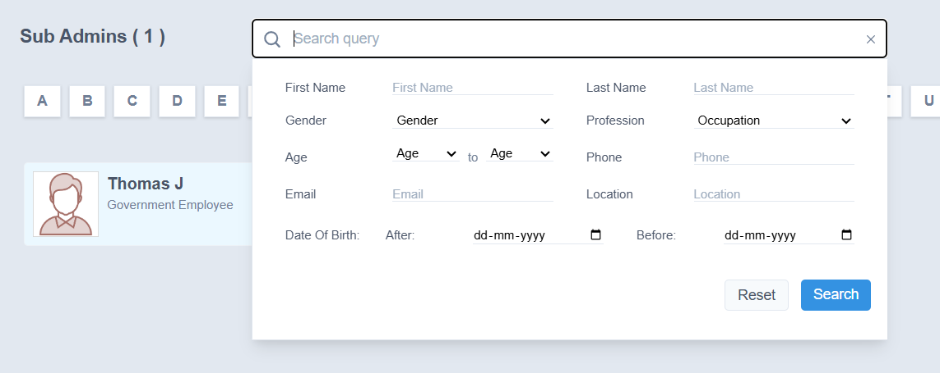

Outcome
- The sub-admin profile will be created successfully.
- The new sub-admin will be listed in the Sub Admins section.

Note
- The Email ID is mandatory as it is used for login and system communication.

To Access the member profile

Go to How to Access Member Profile Actions
- Login to the system using Admin or Staff credentials.
- Navigate to Users → sub admin .
- Click the name and the profile will be opened
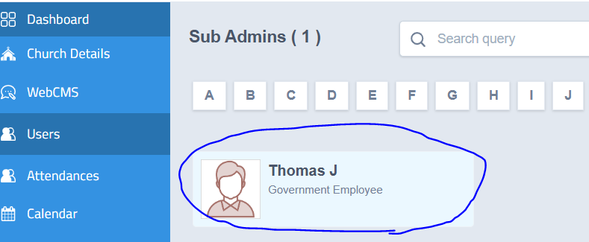

Sub Admin Profile Sections
The following tabs and details can be viewed in the profile:
  - My Profile
  - Timeline
  - Family Tree
  - Family
  - Messages
  - Notes
  - Attendance
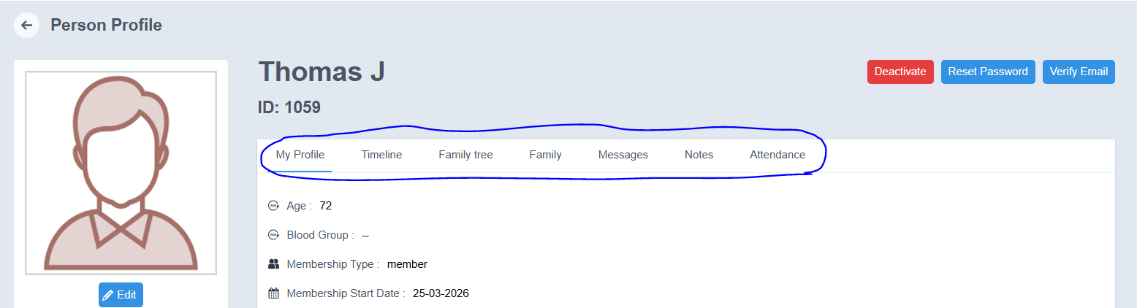

1. Profile
- Displays the complete profile information of the sub admin.
- Includes personal details such as name, contact information, date of birth, and other registered 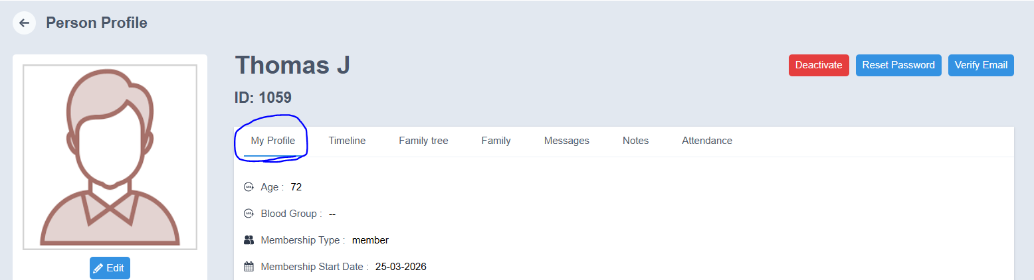details

2. Timeline
- Displays the activity history of the member profile.
- All updates and actions performed in the profile can be viewed here.

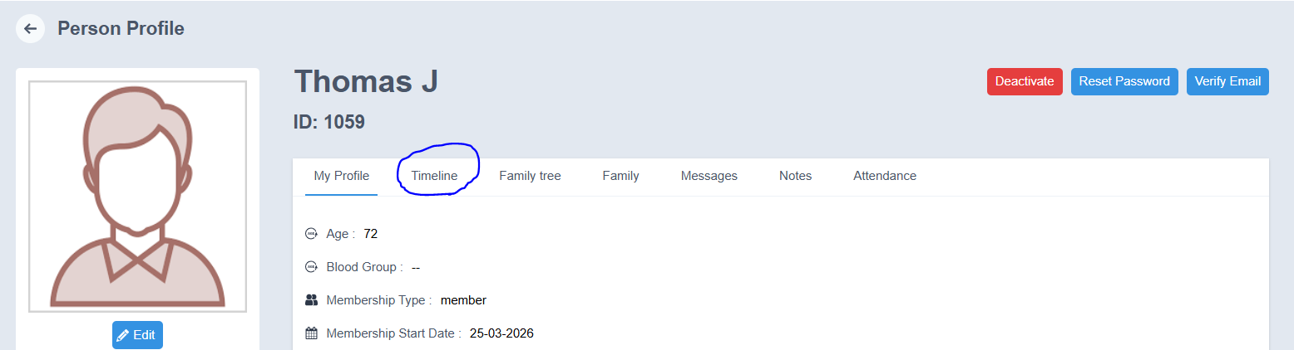

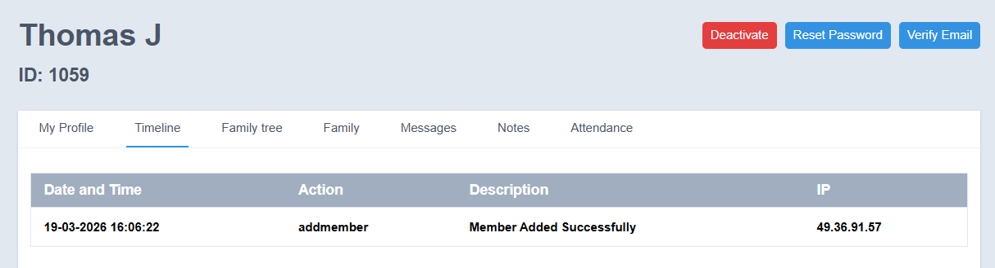

3. Family Tree
- Displays the family details linked to the member.
- Family information such as:
  - Name of the family member
  - Relationship
  - Date of Birth
  - Email ID
  - Other related details
can be viewed here.

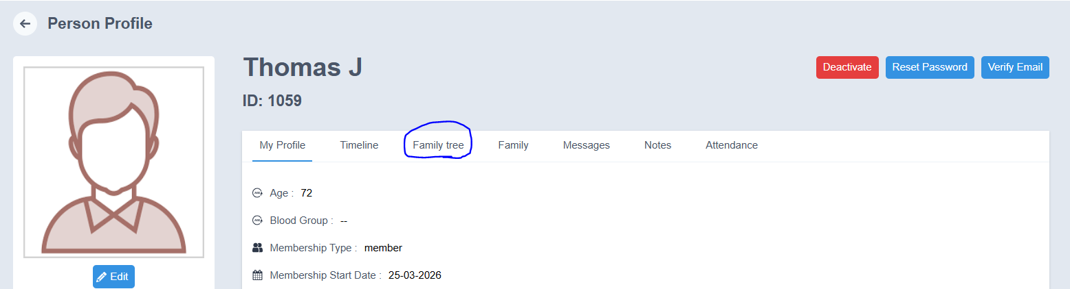

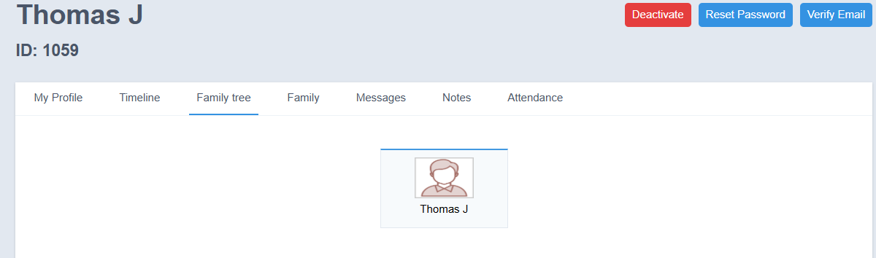
- Family
- Family tree details can be added while creating the member profile in the Users module.

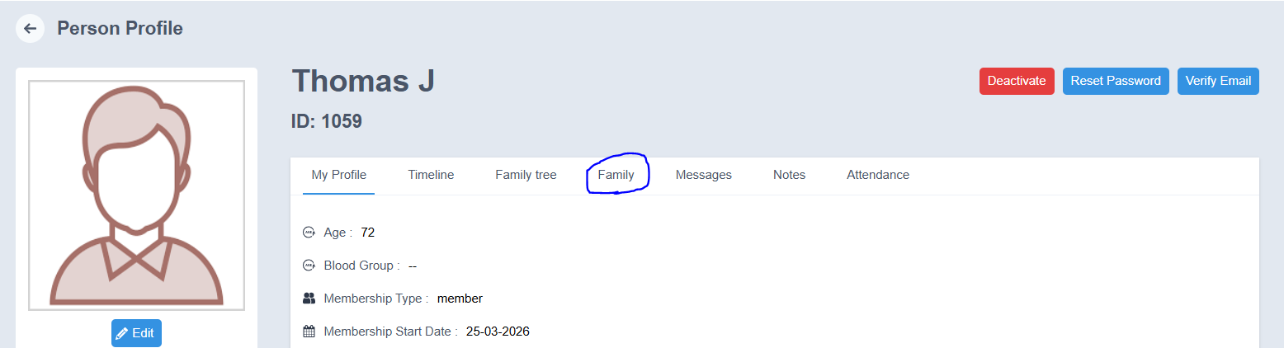

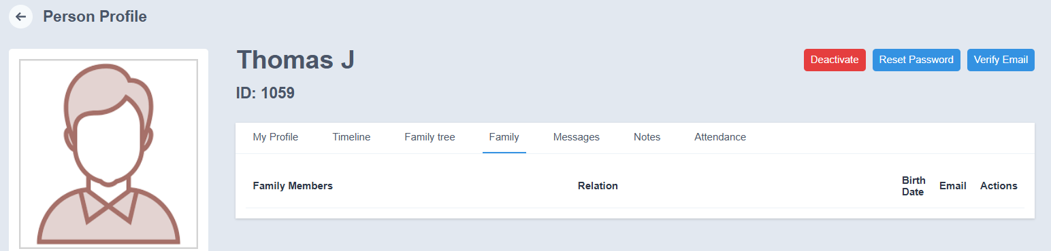

Messages
- Displays messages sent by the member.
- The following details can be viewed:
  - Status
  - Subject
  - Message
  - Attachments
  - Sent On
  - Action

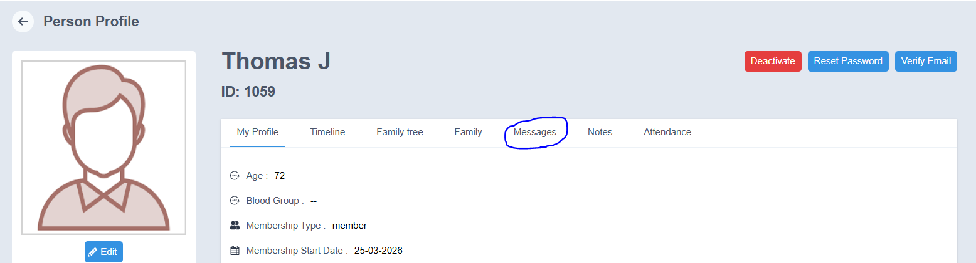

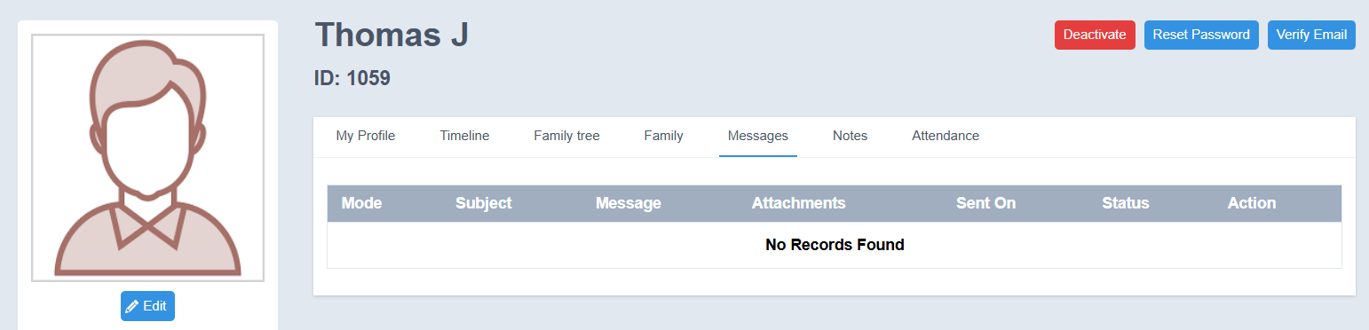

6. Notes
- Admin can add notes related to the member.
- Enter the note in the provided field.
- Click Submit to save the note.

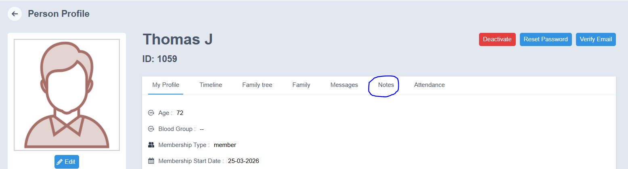

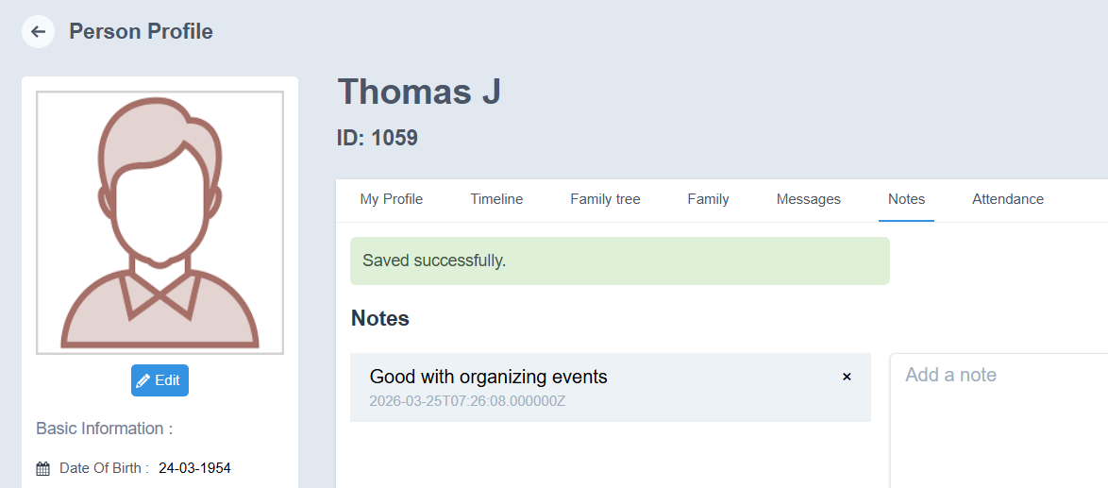

7. Attendance
- The attendance details of the member can be viewed in this section.
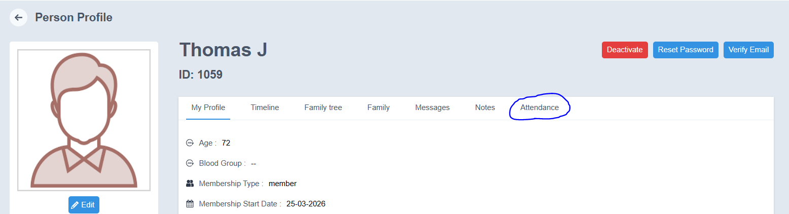
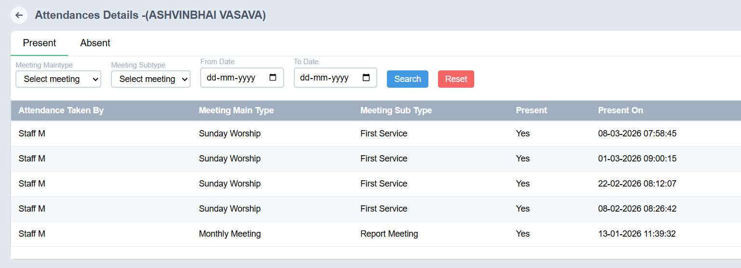

Available Member Profile Actions

Edit Member Profile
- Open the required member profile.
- Click the Edit option.
- Make the necessary changes.
- Click Submit to save the updated details.

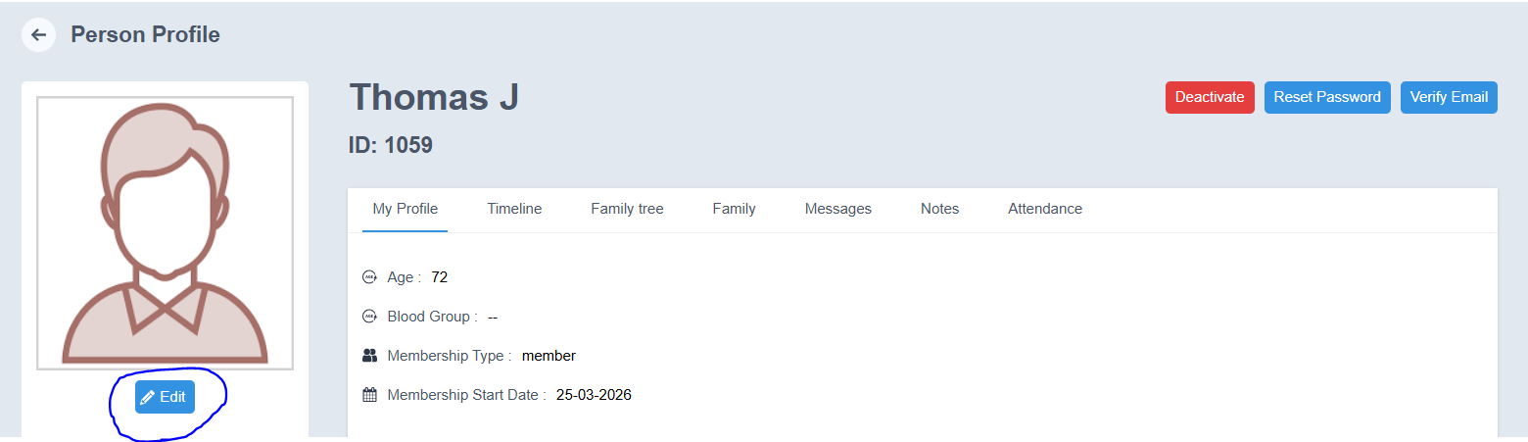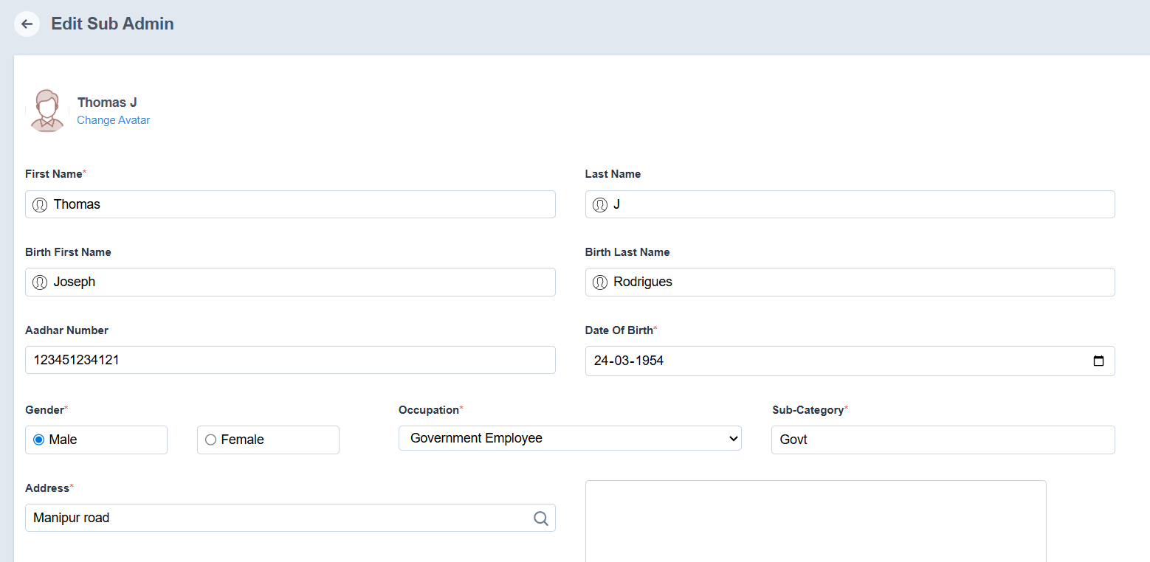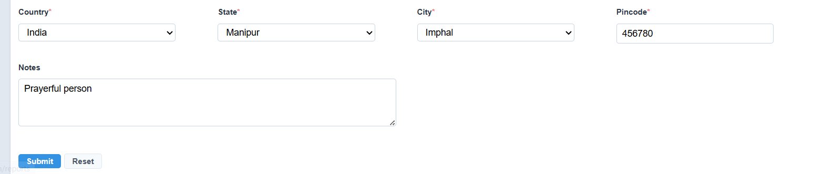

Deactivate Preacher
- Click Deactivate.
- A confirmation message will appear asking whether you want to change the member’s status.
- Click OK.
- The member will be deactivated successfully.

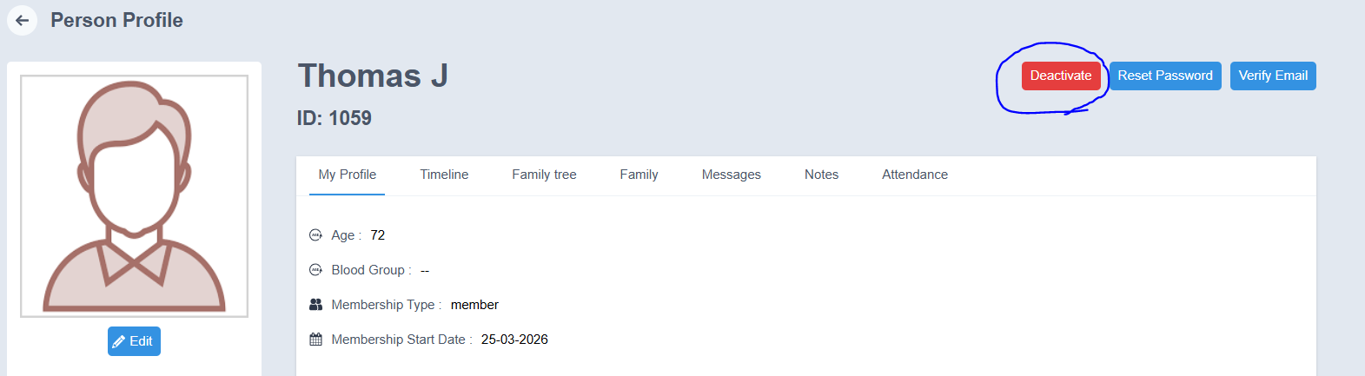
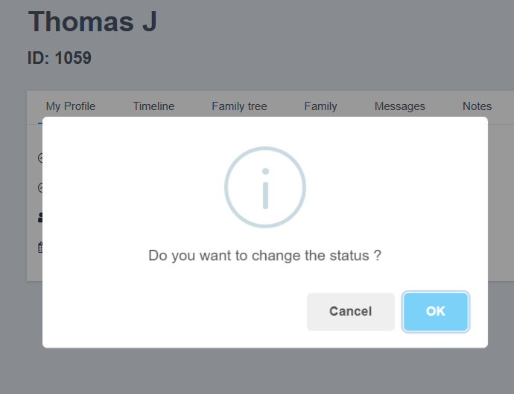

Reset Password
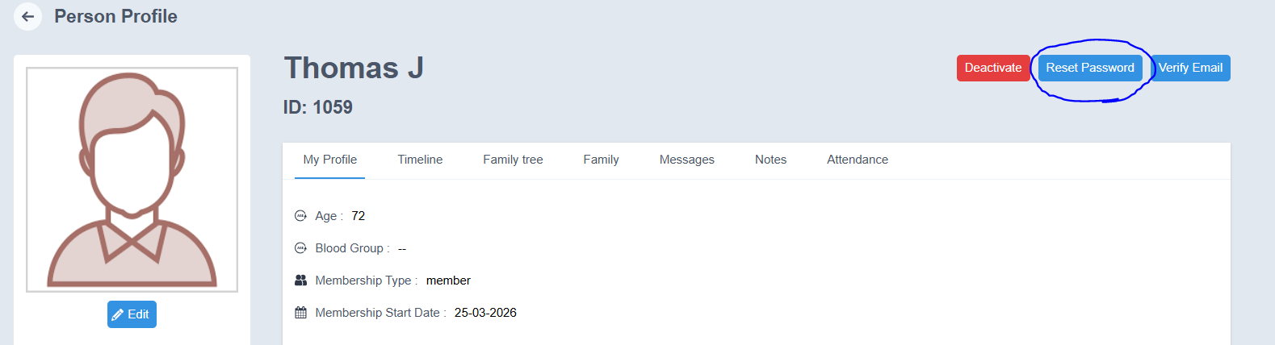
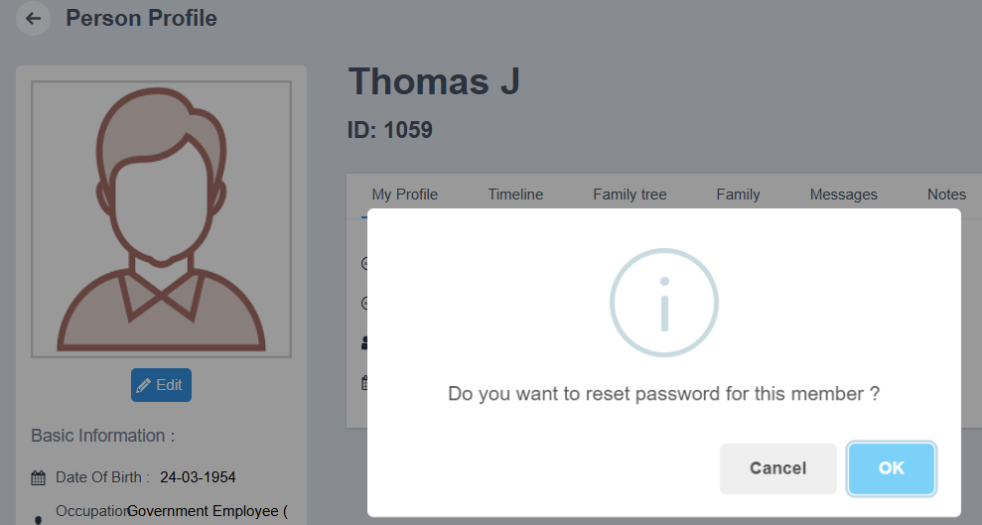

Verify Email
- Click Verify Email.
- A verification email will be sent to the member’s registered email address.
